Expanding Pronominal Feature Geometry: Politeness and Honorifics in Personal Pronoun Systems

Cassidy Amundsen, Erin Humphreys, Jamie Wee

**I. Introduction**

- Background:

- Brief overview of honorifics in linguistic theory.

- Brief overview of feature geometry

- Intro to French, Mandarin Chinese, Tamil, Korean, and English honorific systems.

- Research Questions/Thesis Statement:

- What are the morphological features associated with honorifics in Korean, French, Mandarin Chinese, and Tamil?

- How can feature geometry be applied to analyze the morphological structure of honorifics?

- Assumptions: the politeness feature would be placed where it can be influenced by the person and number feature

- Significance:

- Highlight the importance of understanding honorifics in cross-linguistic research.

- Discuss the relevance of feature geometry in morphological analysis.

The proposed feature geometry by Harley & Ritter (2002) fails to encompass all potential distinctions found in pronominal systems. Some languages exhibit an honorific system that spans diverse contexts and communication styles. Our primary objective is to modify the feature geometry to incorporate politeness distinctions/honorifics in pronoun usage. We will examine English (without distinctions), French (binary distinction), Chinese (binary distinction), Tamil (multiple distinctions - familiar, respectful), and Korean (multiple distinctions - humble, familiar, respectful).

There are three types of honorifics: referent honorifics, hearer honorifics, and bystander honorifics (Brown, 2011). Since referent honorifics mostly deal with the third person and the bystander with the onlookers who are not present in the speech event, the hearer honorifics would be only the ones that are considered in this paper.

We strive to enhance the feature geometry to accommodate these variations in pronoun meanings and features. By integrating these distinctions into the existing feature geometry framework, we aim to address the use of honorifics in expressing respect, formality, and social hierarchy across different languages. Introducing a new node, labeled "HONORIFIC," under the previously established individuation node in the framework, enables us to elucidate the adaptability and universality of feature geometry in morphological analysis. This new node will be employed for a comprehensive exploration of honorific expressions in French, Chinese, Tamil, Korean, and English. The inclusion of this node serves the purpose of updating the previous framework to reflect how languages employ honorifics as markers of politeness and formality.

**II. Literature Review**

- Overview of Honorifics:

- General concepts of honorifics in linguistics. - Pragmatic

(Wang 2023) + (Brown & Levinson 1987) + (Corbett 2012)

- Previous research on Korean, French, Mandarin Chinese, and Tamil honorifics.

- Feature Geometry in Morphology:

- Explain feature geometry and its application in morphology.

- Relevant studies applying feature geometry to linguistic analysis.

**III. Theoretical Framework** (Harley & Ritter 2002)

- Feature Geometry Model:

- Overview of the feature geometry model to be used.

- Explanation of how features related to honorifics can be represented.

**IV. Analysis of French Honorifics**

- Overview of French Honorific System:

- Explanation of honorific expressions in French.

French has a binary respect distinction in the second person pronoun. The singular form *tu* is used for familiar situations, whereas the plural form *vous* is used when talking to someone deserving of respect, even if the addressee is singular.

Isg je 1pl nous

2sg tu 2pl vous

2sgR vous 2plR vous

(Batchelor & Chebli-Saadi, 2011)

We can apply Harley & Ritter’s feature geometry to this with no issues, as the plural second-person pronoun is re-used for the second-person polite pronoun. We can represent this with the standing feature geometry as follows:

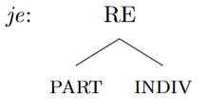 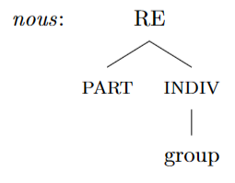

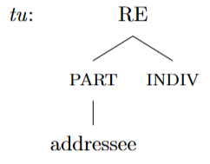 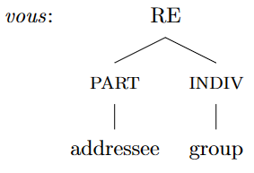

The morphological feature associated with politeness here is the plural form. This, along with the re-use of the third-person pronoun, a dual pronoun, or an indefinite pronoun are ways in which honorification is grammaticalized (Wang 2023). These, though, are grammaticalized as pragmatic discourse strategies, and crucially not as morpho-syntactic features. However, the feature geometry cannot presently represent honorification when it is not done through re-purposing a pre-existing morphological feature for referring expressions.

**V. Analysis of Mandarin Chinese Honorifics**

Mandarin Chinese has the same binary politeness distinction in second-person pronouns, except it does not use the plural form, and instead has a separate polite form. The distinction between the singular and plural in Chinese is portrayed by the same plural marker men0 (们) so the pronouns themselves do not have the plural feature, so plurality does not need to be explored in the feature geometry.

1ex wo3 我 +men2 们 for plural

1in zan2 咱 +men2 们 for plural

2 ni3 你 +men2 们 for plural

2R nin2 您 + # wei4 位 (people classifier)

(Shi 2016)

In Chinese the regular second person and the respectful second person pronoun are different, unrelated forms so respect must be able to be represented by the feature geometry, outside of repurposing other morphosyntactic features. Especially due to the difference in how the two second person forms are made plural, as the familiar second person uses the regular +们 to indicate plurality, whereas a number and person classifier must be used for the respectful form, suggesting a difference in morphosyntactic features. For Chinese, we propose that the respectful feature was housed under the addressee node, giving us the following trees:

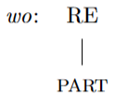 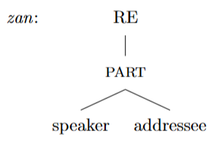

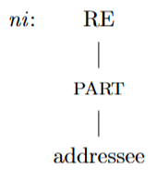 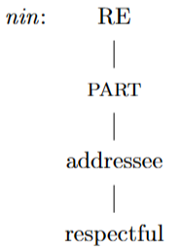

Here we propose that the morphological feature associated with politeness is associated with the addressee node as a subtype of the addressee. Later, we introduce and justify the existence of the HONORIFIC node under INDIVIDUATION, this changes our representation of *nin* to:

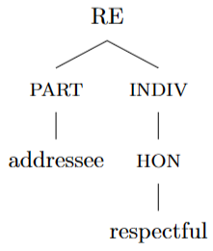

**VI. Analysis of Tamil Honorifics**

Within the context of the feature geometry framework, Tamil requires the inclusion of a designated node labeled "HONORIFIC" under the individuation node included in the previously established feature geometry. This node branches denoting the honorific marked as "respectful". This configuration accommodates the honorifics of Tamil's pronominal system, where the language not only maintains politeness distinctions but further refines them into gradations of formality regarding respectfulness. The addition of the HON node and its subdivisions enhances the feature geometry by representing Tamil’s pronominal system and reinforcing the framework's adaptability to capture the multifaceted nature of honorific expressions in the language.

1sg *naan* 1pl *naam*

2sg (familiar) *nii* 2pl (familiar) *niinkaḷ*

2sg (respectful) *niir* 2pl (respectful) *niinkaḷ*

2sg (more respectful) *niinkaḷ* 2pl (more respectful) *niinkaḷ*

(Helmbrecht, 2013; Brown & Levinson, 1987)

The second person singular pronoun presents in three distinctive forms: familiar, respectful, and more respectful. The most respectful form shares the same form as the second person plural form, letting us know that repurposing another pronoun and having a separate HON node are not mutually exclusive. Tamil maintains a clear distinction between familiar and respectful expressions within the singular pronouns, adhering to a hierarchical framework with three discernible levels of respect. Context in the situation and phrase in which the pronouns appear determine whether the respectful form will be referring to a singular or plural person (Nuhman, 1991). This gives us the following representations:

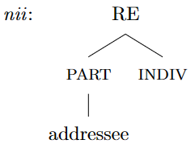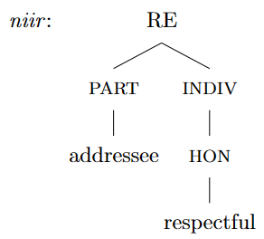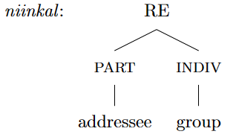

The initial differentiation occurs through the HON node, but the same expression to implement the utmost formality is consistent through all forms of second person pronoun pluralization. Essentially both methods of utilizing respectful expressions coexist, but the plural form is implemented in the most formal scenarios to show respect. Further suggesting that HON should be under the individuation node.

**VII. Analysis of Korean Honorifics**

One of the characteristics of the Korean honorific system that differentiates it from that of French, Chinese, and Tamil is that there is a first person humble pronoun *ce*, *cehuy(tul)*. Humble pronouns are used to exhibit the lower status of the speaker to show respect to the addressee and typically used to talk with one’s family (Kim, Curtis & Cho, 2017; Brown, 2011).

1sg (familiar) *na* 1pl (familiar) *wuli(tul)*

1sg (humble) *ce* 1pl (humble) *cehuy(tul)*

2sg (familiar) *ne* 2pl (familiar) *nehuy(tul)*

2sg (respectful) *kuccok* 2pl (respectful) *kuccoktul*

*caki cakitul*

*kukay kukaytul*

*tangsin tangsintul*

*caney caneytul*

*tayk etc. tayktul etc.*

(Kim, Curtis & Cho, 2017)

Considering that ‘humble’ is a way of showing respect to the addressee but in a different manner from ‘respectful,’ we would suggest adding another node labeled as ‘humble.’ The ‘humble’ node lowers the status of the active node in PARTICIPANT. In this regard, the representation of the first-person humble pronouns would be as follows:

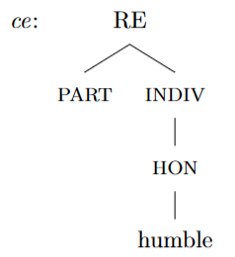 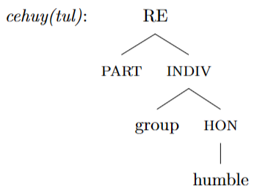

There are varieties of accounts on the inventory of second-person pronouns, but Martin (1992) suggests that there is a second-person inferior pronoun *ce*(sg.) and *cetul*(pl.) that are used to exhibit the lower status of the addressee compared to the speaker. Inferior pronouns can be represented on the feature geometry using the ‘humble’ node: if the ‘addressee’ is the only node active under the PARTICIPANT and ‘humble’ is present under HONORIFIC, ‘humble’ lowers the status of the ‘addressee’ and allows for the inferiority reading.

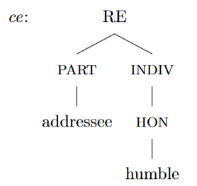 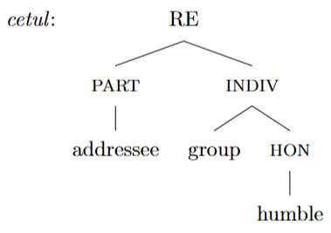

Another notable feature of the Korean honorific system is that multiple second-person pronouns show an honor to the addressee by using the ‘respectful’ feature. They all are used to respect the addressee, but the context where each of them varies based on comparative social status and familiarity of the relationship (Kim, Curtis & Cho, 2017). The representation of complicated interpersonal relationships and social status necessarily involves the pragmatic sphere, so features would not be used to explain the differences among them.

**VIII. Analysis of Honorifics in languages that don’t have honorific distinctions**

English is one of the languages that does not have a pronominal honorific distinction. One might think the removal of the HONORIFIC node can represent the languages that don't have the honorific distinction. Instead, we adopted to use the 'familiar' node as default rather than removal of the HONORIFIC node altogether. ‘Familiar’ feature is used to represent pronouns without politeness distinctions, plain pronouns. In French, Chinese, Korean, and Tamil, both first and second person pronouns have the familiar pronoun as a default expression. This supports the claim that languages with pronominal honorifics are a subset of the languages without pronominal honorific distinctions. Therefore, the non-honorific feature, or familiar, should be the default for the honorific node. Based on this assumption, we are suggesting the following diagram as a way to incorporate honorifics into the feature geometry.

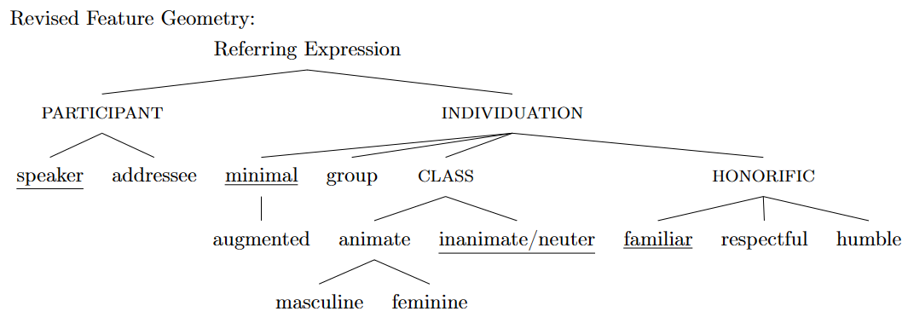

**IX. Discussion**

- Theoretical Implications:

- Contribution of the study to the understanding of honorifics in feature geometry.

- Implications for cross-linguistic morphological analysis.

* Quick test application to: (Pertsova 2022)
  + Vietnamese
  + Khmer
  + Semelai

- Limitations and Future Research:

- Acknowledgment of study limitations.

- Suggestions for future research in this area.

**X. Conclusion**

- Recap of key findings regarding honorifics in French/Chinese/Tamil/Korean.

- Reiteration of the relevance of feature geometry.

- Closing Remarks:

- Reflection on significance of the study.

- Encouragement for further research on honorifics and feature geometry.

**XI. References**

Batchelor, R., & Chebli-Saadi, M. (2011). Personal pronouns and pronouns as objects/Les pronoms personnels, les pronoms comme objets. In A Reference Grammar of French (Reference Grammars, pp. 435-451). Cambridge: Cambridge University Press. doi:10.1017/CBO9780511921872.047

Brown, L. (2011). Korean honorifics and politeness in second language learning. *Korean Honorifics and Politeness in Second Language Learning*, 1-328.

Brown, P. & Levinson, S. (1987). Politeness: Some universals in language usage. Cambridge University Press, Cambridge

Corbett, G. (2012). Features (Cambridge Textbooks in Linguistics). Cambridge: Cambridge University Press. doi:10.1017/CBO9781139206983

Harley, H & Ritter, E. (2002) Structuring the bundle: A universal morphosyntactic feature geometry. In Simon, H. J., & Wiese, H. (Eds.). *Pronouns – grammar and representation* (pp.23-39). John Benjamins Publishing Company.

Helmbrecht, J. (2013). Politeness Distinctions in Pronouns. In M. S. Dryer & M. Haspelmath (Eds.), WALS Online (v2020.3) [Data set]. Zenodo. https://doi.org/10.5281/zenodo.7385533

Kim, S., Curtis, E., & Cho, H. (2017). *Korean grammar: The complete guide to speaking Korean naturally*. North Clarendon, VT: Tuttle publishing.

Martin, S. E. (1992). A Reference Grammar of Korean, Charles E. *Tuttle Company, Rutland, Vermont*.

McAlpin, David W. *A core vocabulary for Tamil*. Rev. ed. Philadelphia, Pa.: Dept. of South Asia Regional Studies, University of Pennsylvania, 1981.

Nuhman, M. A. (1991). Pronominal systems in Tamil and Sinhala. http://dlib.pdn.ac.lk/bitstream/123456789/2217/1/M.A.Nuhman%20Vol.XVII%20%26%20XVIII%201991-1992%20No.01%20%26%2002.pdf

Pertsova, K. (2022). PRONOM. https://doi.org/10.17615/h78a-9w72

Puškar-Gallien, Z., (2019) “Resolving polite conflicts in predicate agreement”, Glossa: a journal of general linguistics 4(1): 33. doi: https://doi.org/10.5334/gjgl.587

Selvanathan, N. (2017). Cleft constructions in Tamil and anti-agreement. *Manuscript, lingbuzz/003681. https://ling. auf. net/lingbuzz/003681*.

Shi, D. (2016). Nouns and nominal phrases. In C. Huang & D. Shi (Eds.), A Reference Grammar of Chinese (Reference Grammars, pp. 199-255). Cambridge: Cambridge University Press. doi:10.1017/CBO9781139028462.009

Wang, R. (2023) *Honorifics without [HON]*. Natural Language & Linguistic Theory 41:1287–1347 https://doi.org/10.1007/s11049-022-09563-0

Wier, Thomas. 2006. Feature geometry and the morphosyntax of the Algonquian languages. In Proceedings of WIGL 2006, ed. by Blake Rodgers. Available at http://ling.wisc.edu/lso/wpl/6/weir.pdf.

Wiese, H & Simon, H. (2002) Grammatical properties of pronouns and their representation: An exposition. In Simon, H. J., & Wiese, H. (Eds.). Pronouns – grammar and representation (pp.1-21). John Benjamins Publishing Company.